https://en.wikipedia.org/wiki/Automotive_aerodynamics

Turbulent Flow
Snippets from a book that I saw recommended in a “Race Car Aerodynamics” introduction lecture. (Turbulent Flow by Pope)

“As is discussed in detail in Chapter 6, at high Reynolds number there is a separation of scales. The large-scale motions are strongly influenced by the geometry of the flow (i.e., by the boundary conditions), and they control the transport and mixing. The behavior of the small-scale motions, on the other hand, is determined almost entirely by the rate at which they receive energy from the large scales, and by the viscosity. Hence these small-scale motions have a universal character, independent of the flow geometry. It is natural to ask what the characteristics of the small-scale motions are. Can they be predicted from the equations governing fluid motion? These are questions of turbulence theory, which are addressed in the books of Batchelor (1953), Monin and Yaglom (1975), Panchev (l971), Lesieur (1990), McComb (1990), and others, and that are touched on only slightly in this book (in Chapter 6).” P7

“However, in the context of turbulent flows, their power is also their weakness: the equations describe every detail of the turbulent velocity field from the largest to the smallest length and time scales. The amount of information contained in the velocity field is vast, and as a consequence (in general) the direct approach of solving the Navier-Stokes equations is impossible. So, while the NavierStokes equations accurately describe turbulent flows, they do not provide a tractable model for them” P8

“For the high-Reynolds-number flows that are prcvalent in applications, the natural alternative is to. pursue a statistical approach. That is, to describe the turbulent flow, not in terms of the velocity U(x, t), but in terms of some statistics, the simplest being the mean velocity field (U(x, t)). A model based on such statistics can lead to a tractable set of equations, because statistical fields vary smoothly (if at all) in position and time. In Chapter 3 we present the concepts and techniques used in the statistical representation of turbulent I .Z The study of turbulent flows Y flow fields; while in Part I1 we describe statistical models that can be used to calculate the properties of turbulent flows. The approaches described include: turbulent viscosity models, e.g., the k-E model (Chapter 10); Reynolds-stress models (Chapter 11); models based on the probability density function (PDF) of velocity (Chapter 12); and large-eddy-simulations (LES) (Chapter 13).” P8-9
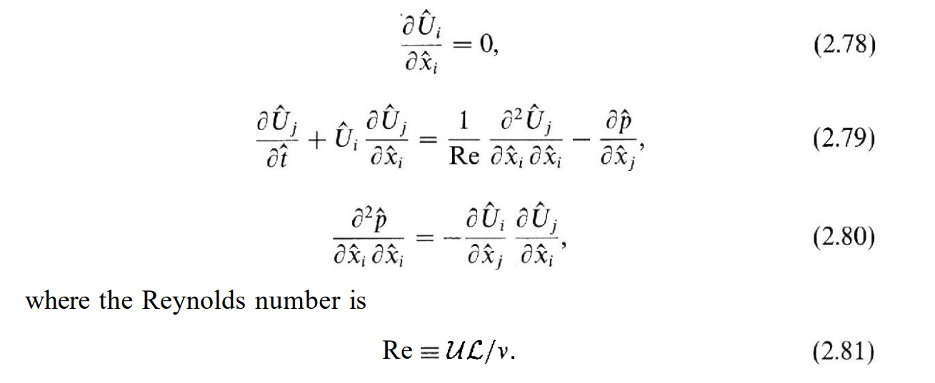

Formula 1.com Aerodynamics
“As a result, today’s aerodynamicists have considerably less freedom than their counterparts from the past, with strict rules dictating the height, width and location of bodywork. However, with every additional kilogram of downforce equating to several milliseconds of lap time saved, the teams still invest considerable amounts of time and money into wind tunnel programmes and computational fluid dynamics (CFD) – the two main forms of aerodynamic research. “

Professional Aerodynamics (for e.g. Race cars)
Use enormous meshes (5 million+ elements), machines with multiple Nvidia Quadro Pci cards (e.g. Quadro P6000, 3840 cores, 24 GB GDDR5X, 12 TFLOPS, 5200 euro price tag) per machine. In essence, each workstation will have something like 12 cluster nodes for each videocard added to the machine or some 200 cluster cores per videocard. (cluster nodes and cores compared to our Maris cluster, estimated by comparison to teraflop i9 https://www.zdnet.com/article/intel-unveils-monster-18-core-core-i9-first-teraflop-speed-consumer-pc-chip/ . The processors in the cluster nodes are similar or slightly inferior to the i9-7980XE).
https://www.nvidia.com/en-us/data-center/gpu-accelerated-applications/catalog/
As an example, although this one would likely be more of a server-node: https://www.asus.com/us/Commercial-Servers-Workstations/ESC4000_G3S/

